Brotherhood for the Fallen is proud to support American Legion Post 460 Brotherhood is a 501 (c)(3) fraternal organization made up of NYPD officers and those who support us. We send NYPD MOS to every line-of-duty funeral in the U.S., ensuring NYPD is always represented, lending emotional support and giving money directly to the family of the fallen. Please visit our website and support our mission or

become a member of the Brotherhood!

[www.brotherhoodnyc.org](http://www.brotherhoodnyc.org)

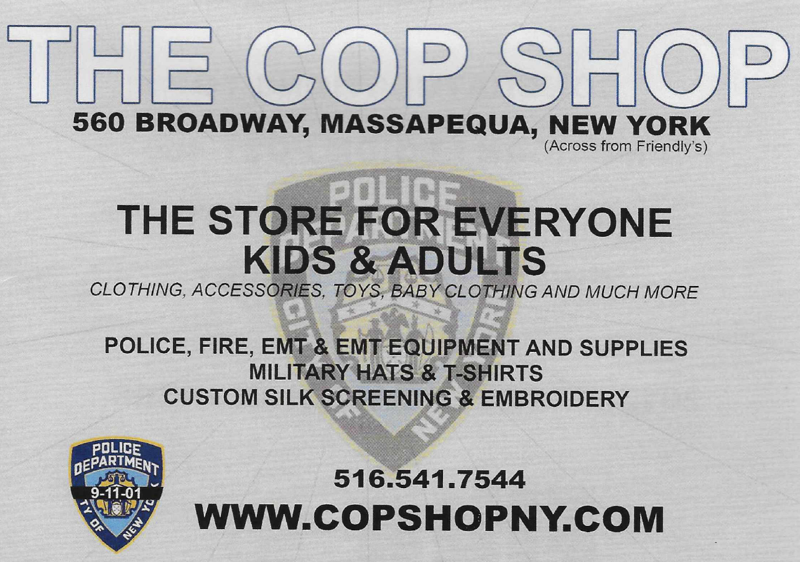

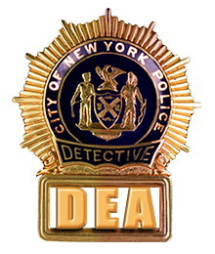

THE DETECTIVES' ENDOWMENT ASSOCIATION, INC. Police Department • City of New York

salutes

AMERICAN LEGION POST 460





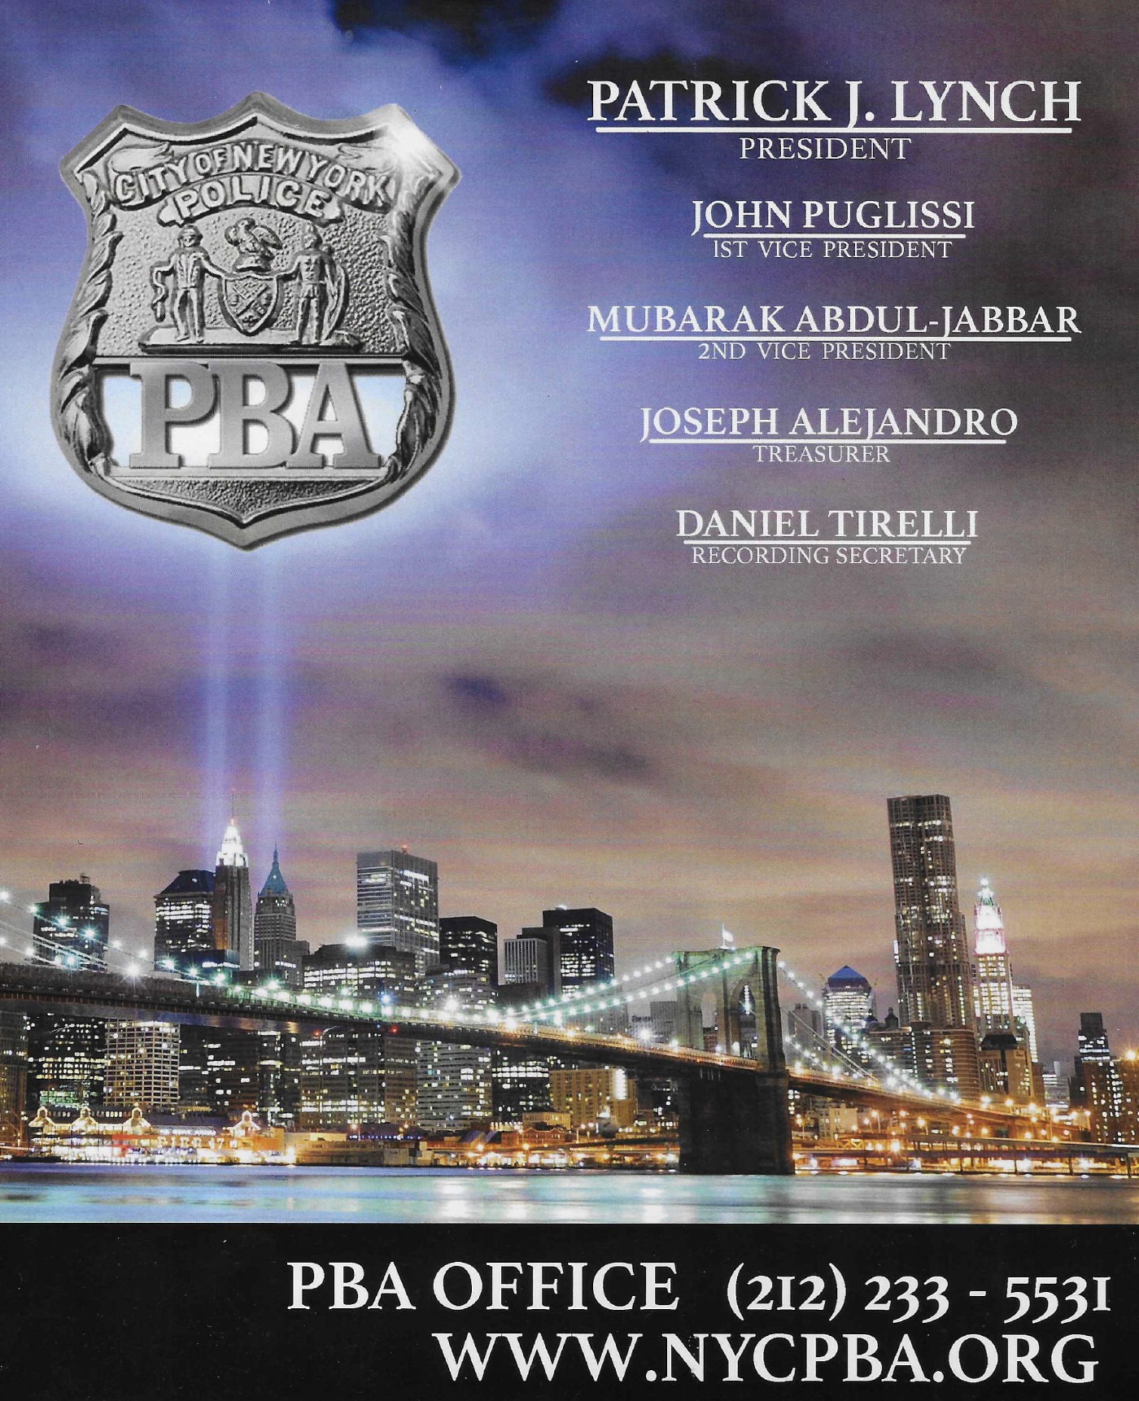

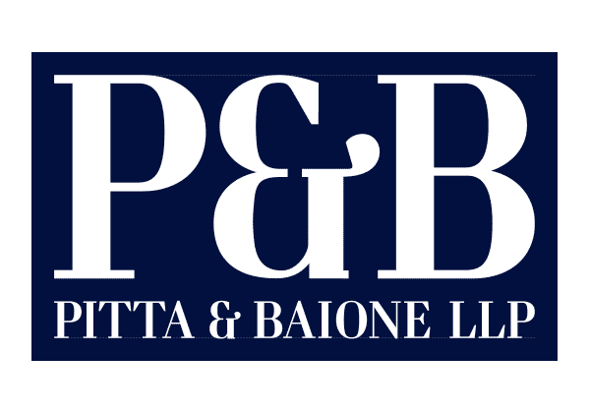

9/11 VICTIM COMPENSATION FUND CLAIMS

info@pittabaione.com

(844) WTC-COMP

https://www.911benefits.com/